**Task1: Customer Segmentation of Retail Store**

**CODE:**

#all imports

import pandas as pd

import numpy as np

import matplotlib.pyplot as plt

import seaborn as sns

#import csv file

from google.colab import files

uploaded = files.upload()

df=pd.read_csv('Mall_Customers.csv')

df.head(10)#first 10 rows

#shape

df.shape

#info

df.info()

X= df.iloc[:,[3,4]].values

X

#using kmeans

from sklearn.cluster import KMeans

wcss = []

for i in range (1,11):

  kmeans= KMeans(n_clusters=i, init='k-means++', random_state=0)

  kmeans.fit(X)

  wcss.append(kmeans.inertia_)

# Elbow method representation in the form of graph

plt.plot(range(1,11),wcss)

plt.title('The elbow method')

plt.xlabel('n0. of clusters')

plt.ylabel('WCSS Values')

plt.show()

# 5 clusters

kmeansmodel= KMeans(n_clusters=5, init='k-means++',random_state=0)

y_kmeans= kmeansmodel.fit_predict(X)

#plotting the clusters

plt.scatter(X[y_kmeans == 0,0], X[y_kmeans == 0,1], s=80, c='red', label='Cluster 1')

plt.scatter(X[y_kmeans == 1,0], X[y_kmeans == 1,1], s=80, c='blue', label='Cluster 2')

plt.scatter(X[y_kmeans == 2,0], X[y_kmeans == 2,1], s=80, c='yellow', label='Cluster 3')

plt.scatter(X[y_kmeans == 3,0], X[y_kmeans == 3,1], s=80, c='purple', label='Cluster 4')

plt.scatter(X[y_kmeans == 4,0], X[y_kmeans == 4,1], s=80, c='black', label='Cluster 5')

#for center point of each clusters

plt.scatter(kmeansmodel.cluster_centers_[:,0], kmeansmodel.cluster_centers_[:,1], s=100, c='cyan', label='Centroids')

plt.title('Clusters of customers')

plt.xlabel('Annual Income (k$)')

plt.ylabel('Spending Score (1-100)')

plt.legend()

plt.show()

# Pie chart representation

# Count the number of customers in each cluster

unique, counts = np.unique(y_kmeans, return_counts=True)

# Pie chart to show the proportion of each cluster

plt.figure(figsize=(5, 5))

plt.pie(counts, labels=[f'Customer {i+1}' for i in unique], autopct='%1.1f%%', colors=['red', 'blue', 'green', 'cyan', 'black'], startangle=140)

# Add a title

plt.title('Proportion of Customers in Each Cluster')

# Display the pie chart

plt.show()

**Elbow method representation on Chart:**

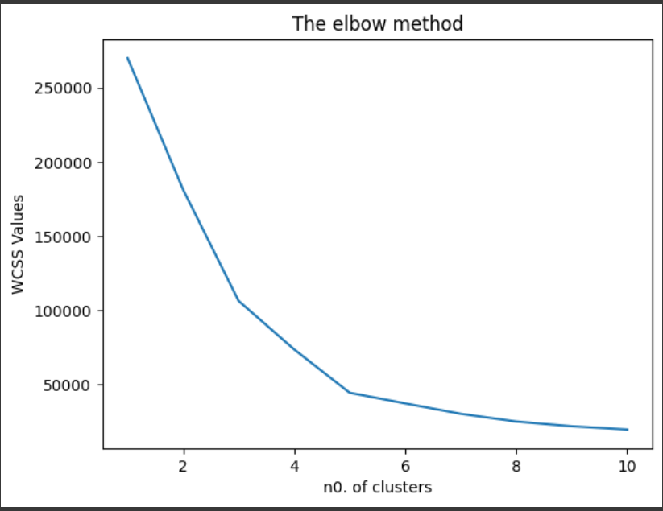

**Clusters representation on Chart:**

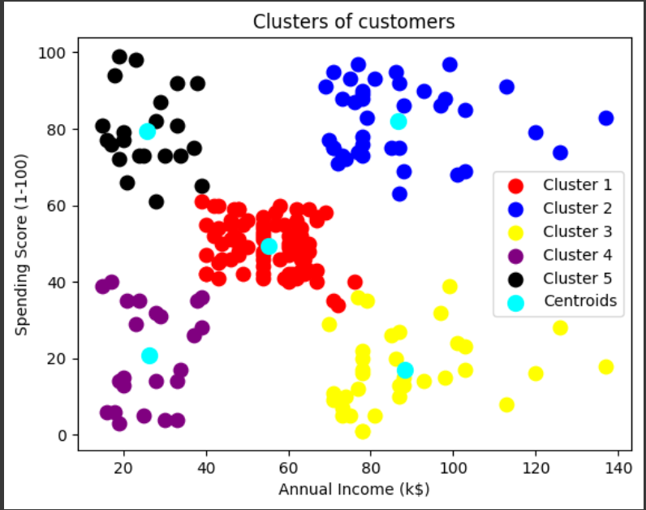

**Clusters representation on pie-Chart:**

